|  |  |
| --- | --- |
|  |  |



Email: info@AirSolutions.com

Website: www.AirSolutions.com

Air Solutions

BUSINESS

REPORT

Jae Hoon Lee, Data Analysist

[JLee@Airsolutions.com](mailto:JLee@Airsolutions.com)

Moises Cervantes, Data Analysist

[MCervanet@AirSoultions.com](mailto:MCervanet@AirSoultions.com)

Jasmine Romero, Data Analysist

[JRomero@AirSolutions.com](mailto:JRomero@AirSolutions.com)

Table of Contents

Global Warming 2

BusinessUnderstanding 2

Business Objectives 3

Assess the Situation 4

Data Analysis Goals 7

Initial Data Collection 8

Describe Data 11

Explore Data 15

Verify Data Quality 22

Data Preparation 23

Select Data 23

Evaluation 42

Deployment 43

Conclusion 45

Glossary 46

References 48

|  |
| --- |
| Global Warming |

## BusinessUnderstanding

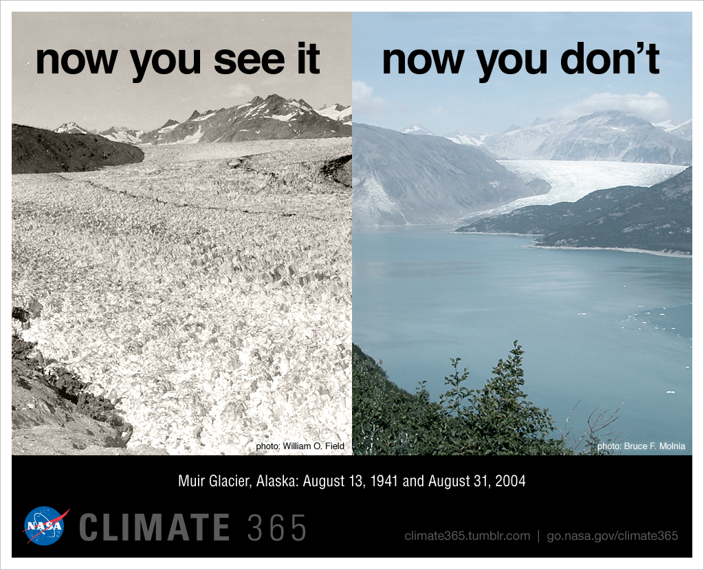

The data we gathered measures the global changes that have been caused by CO2 emissions. Emissions have increased the greenhouse effect of the Earth’s atmosphere, creating global warming. If global warming continues at this rate, it will result in disruption to orderly government, as well as an influx of environmental immigrants due to loss of inhabitable land.

### Business Objectives

* One of the problem areas that needs to be addressed are ongoing CO2 emissions. CO2 emissions are one of the key factors in global warming. Global warming has resulted in the melting of the land ice sheets in Antarctica and Greenland, causing rising sea levels. Continued emissions at this rate will result in significant loss of livable land and will result in the displacement of 10% of the world’s population. In addition, many plant species will go extinct. The impact of their extinction should not be minimized as this will, in turn, result in food and freshwater shortages.
* The key problem in preventing important changes being made is the lack of incentives for businesses to make changes that could decrease their profitability and for governments to enact legislation that could decrease a country’s economic health. Changes in the global economy, however, could minimize these disincentives. The European Parliament agreed to reduce CO2 emissions of automobiles by 37.5% by 2030. In Britain, sales of new diesel and gas cars will be banned by 2035. Automakers violating these penalties face huge penalties. Failing to follow the trend for more environmentally friendly automobiles will have a huge negative impact on business.
* In the Fourth Industrial Revolution, electric engines have shown to have huge advantages over combustion engines in autonomous vehicles.
* These factors should incentivize businesses in participating in CO2 reduction.

#### Business Success Criteria

* Analytics result that support the implementation of legislation which will result in the reduction of CO2 emissions by manufacturers and energy companies by 60% by 2040.

### Assess the Situation

#### Inventory of Resources

* Research labs such as NASA, observe and analysis to study changing in CO2, Global Temperature, Ice Sheet, and Sea level.
* Science conferences for experts, and public to inform the Global Warming.
* Civilian activities, social media awareness, schools from all levels, clubs and organizations such as, YMCA’s, Rotary, and California Naturalists.
* <https://climate.nasa.gov/>

#### Requirements, Assumptions, and Constraints

* Assumption: Governments are aware of the dangers resulting from global warming. Governments are short-sighted and are motivated by economic concerns. In addition, businesses are self-interested and are motivated by short term profits rather than environmental concerns.
* Data Quality: The data from NASA is highly credible and is easily accessible. NASA has objectively measured the negative effects of global warming, as it relates to reduction of ice sheets, rising sea levels, and negative changes to the atmosphere. Data regarding CO2 levels have been documented since 1958 and data regarding ice sheets from 2002. We are therefore limited in comparing the data sets which could cause detractors to claim that the correlation between CO2 and sea levels has not been definitively established.
* 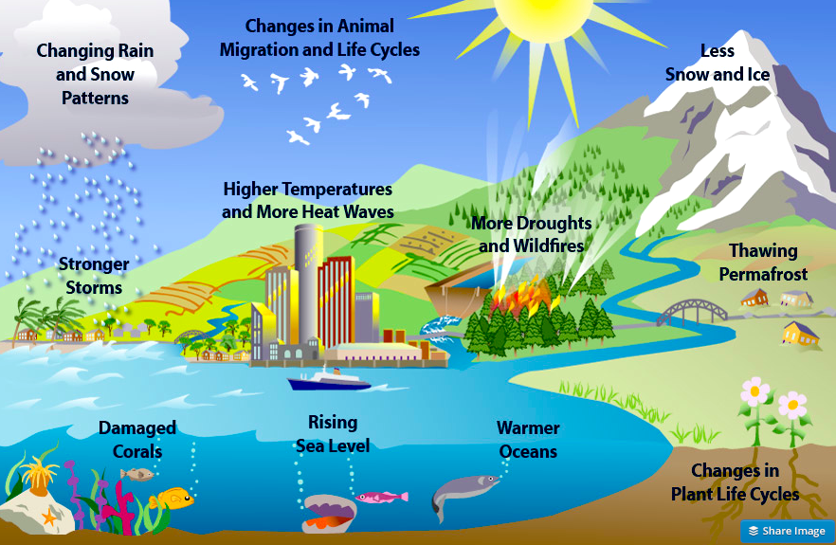External Factors: Businesses wish to remain profitable and competitive. The traditional view is that in order to be profitable, businesses would have to utilize cheaper resources which have depleted the environment and contributed to global warming. The increased frequency and severity of natural disasters, however, are bringing to light the importance of reversing climate change. In addition, companies are operating more globally. Changes in the laws of more environmentally forward countries make it imperative for businesses to change their business practices in order to remain profitable.

(Here CO2 levels in cities cause rising temperatures and rising sea *levels that* affect the *global* environment)

#### Risks and contingencies

* Disasters, such has tornados or hurricanes; political drama, such as the impeachment process; and other national emergencies, such as the COVID-19 virus; command more immediate attention than that of environmental concerns.
* The environment must continue to remain a priority and so information regarding how changes to the environment could alleviate or prevent tragedies should continually be publicized.
* Politically, lobbyists, could delay implementation of important legislative changes. Politicians must be made keenly aware of how environmental changes can positively affect the economies of their individual states and how failing to implement these changes could result in tragedy.
* Businesses also need to be provided with correct CO2 emission information and data. For example, there was a huge outcry after Volkswagen and Mitsubishi were found to be cheating CO2 emissions in their diesel vehicles.
* Decrease CO2 levels to under 200 ppm in the next 20 years to reserve global warming and avert the climate crisis.

### Data Analysis Goals

* Description
* We aim to show how there is a relation between the changing CO2 level, the global temperature, sea levels, and melting ice glacier.
* Dependency
  + - Analyze whether CO2 and global temperature have a positive correlation.
    - Analyze whether global temperature and ice sheet have a negative correlation.
    - Analyze whether global temperature and sea level rising have a positive correlation.
* Prediction
  + - Find the correlation and regression on CO2 levels and global temperature to determine if global warming is leading to rising sea levels. Therefore, reduce CO2 level under 200 ppm by 2040.
    - The prediction is that we expect global temperature to increase in with increasing CO2 levels.
    - We predict that CO2, global temperature, ice melting, and sea level rising how it will affect our environment and living areas.

### Initial Data Collection

* Specify selection criteria: The selection criteria are the CO2 level, global temperature, sea level, and ice sheets since we are studying climate change.
* Tools: We will use Excel software with Stats Tools add-in to analyze correlation and run regression analysis to visualize our data.
* Carbon Dioxide: Carbon dioxide (CO2) is an important heat-trapping (greenhouse) gas, which is released through human activities such as deforestation and burning fossil fuels, as well as natural processes such as respiration and volcanic eruptions. The first graph shows atmospheric CO2 levels measured at Mauna Loa Observatory, Hawaii, in recent years, with average seasonal cycle removed. The second graph shows CO2 levels during the last three glacial cycles, as reconstructed from ice cores.

The time series below shows global distribution and variation of the concentration of mid-tropospheric carbon dioxide in parts per million (ppm). The overall color of the map shifts toward the red with advancing time due to the annual increase of CO2 (Nasa, 2020).

* Global Temperature: In the natural sciences, especially in atmospheric and Earth sciences involving applied statistics, an anomaly is the deviation in a quantity from its expected value, e.g., the difference between a measurement and a mean or a model prediction.
* Sea Level: Sea level rise is caused primarily by two factors related to global warming: the added water from melting ice sheets and glaciers and the expansion of seawater as it warms. The first graph tracks the change in sea level since 1993 as observed by satellites (Nasa, 2020).
* Ice Sheets: Data from NASA's GRACE and GRACE Follow-On satellites show that the land ice sheets in both Antarctica (upper chart) and Greenland (lower chart) have been losing mass since 2002. The GRACE mission concluded science operations in June 2017(Nasa, 2020).

### Describe Data





|  |  |  |
| --- | --- | --- |
|  |  |  |
| Numerical: Continuous (Time Series ) | Summary by time period (Yearly) | GMLS |
| Attribute/Variable Name | Mean | 2.82 |
| Global sea level | Variance | 596.49 |
|  | Std. Dev. | 24.42 |
| Data Volume (number of observation/rows) | Skewness | 0.3401 |
| 27 | Kurtosis | 2.0342 |
|  | Median | 0.07 |
| Meaning of the attribute | Mean Abs. Dev. | 20.02 |
|  | Mode | -30.01 |
| Rising sea level | Minimum | -33.82 |
|  | Maximum | 48.60 |
| Meaning of the attribute in business terms | Range | 82.42 |
|  | Count | 27 |
|  | Sum | 76.19 |
|  | 1st Quartile | -20.26 |
| Attribute types (select from the list) | 3rd Quartile | 22.03 |
| Continuous | Interquartile Range | 42.29 |
|  | Missing / Blank | 113 |





### Explore Data

|  |  |  |
| --- | --- | --- |
| Data Type | Summary measures | Global Temperature Abnormality (C) |
| Numerical | Mean | Mean of global temperature abnormality is positive. It means global temperature have been going up since 1880. |
| Variable Name | Skewness | Skewness is positive, so there is outlier values. |
|  | Kurtosis | Kurtosis is 3.048, so there are normal number of outliers. |
|  | Median | Median is -0.07°C lower than Mean 0.0431°C. It means global temperature getting hotter. |
|  | Mode | The mode is the most frequently occurring number. A negative temperature abnormality means that it is cold. Because the value of -0.22 occurs frequently we can assume that the temperature was very cold before 1950 because most of these values were observed before 1950. |
|  | Minimum | Minimum value is -0.48 that lowest temperature abnormality. |
|  | Maximum | Maximum value is 1.02 that highest temperature abnormality. |
|  | Range | 1.5°C is big difference in bad mean climate science |

*This graph illustrates the change in global surface temperature relative to 1951-1980 average temperatures. Nineteen of the 20 warmest years all have occurred since 2001, with the exception of 1998. The year 2016 ranks as the warmest on record. (Source:*[*NASA/GISS*](https://data.giss.nasa.gov/gistemp/graphs/graph_data/Global_Mean_Estimates_based_on_Land_and_Ocean_Data/graph.txt)*). This research is broadly consistent with similar constructions prepared by the*[*Climatic Research Unit*](http://www.cru.uea.ac.uk/)*and the*[*National Oceanic and Atmospheric Administration*](http://www.noaa.gov/) *(Nasa, 2020).*

|  |  |
| --- | --- |
| Summary measures | CO2 AVG. PPM |
| Mean | The CO2 average ppm (parts per million) is the amount of CO2 emitted into the atmosphere. The Mean of CO2 average ppm is 350.47. The Mean shows an increase from the Minimum which indicates an increasing CO2 level harming our environment. |
| Skewness | The negative skewness describes how CO2 is constantly increasing over the years. |
| Kurtosis | The positive kurtosis describes how CO2 emission is accelerating in an upward movement. |
| Median | The median shows how the middle ppm is 351.57 and is slightly below the Mean which indicates that there are already high CO2 levels, but also that the CO2 levels seem to increase dramatically yet. |
| Mode | The mode tells us that the number 318ppm is a high number for the levels of CO2 which indicates that there are constantly high CO2 levels. |
| Minimum | The minimum shows the lowest CO2 level that was recorded which is relatively low if you compare it to future years. |
| Maximum | The maximum showed the highest level of CO2 recorded which was close to the Mean, which shows that there are increasing CO2 levels. |
| Range | The range shows how there is a dramatic increase from the Minimum CO2 level and the highest CO2 level throughout the years. |

*This graph illustrates our data’s linear progression of Average of CO2 ppm throughout the years.*

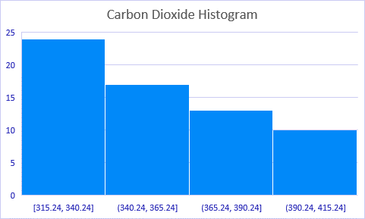

|  |  |  |
| --- | --- | --- |
|  |  |  |
| Data Type | Summary measures | GMSL |
| Numerical | Mean | We are assessing the factors that are impacting catastrophic weather patterns and coastal erosion. The mean that has been calculated for global mean sea level is 2.8 millimeters per year. Since the mean is very sensitive, we must explore the possibilities of any outliers affecting the average. |
| Variable Name | Skewness | Our skewness is at .3401, this means that most of our data is positive and skewed to the right. We have to explore if the skewness is being affected by years past or current years. |
|  | Kurtosis | The positive fatness of kurtosis is 2.0342. |
|  | Median | The median value is significantly different from our mean at 0.07 it it significantly lower. It is more representative of the middle half of higher and lower values. We have to examine further if there are any outliers causing this difference. |
|  | Mode | We have to explore if the mode is affected by seasonality or if its caused by other factors. Since it is a continous data set it is difficult to get an accurate mode. |
|  | Minimum | The data we are assesing is about rising sea levels. We need to asses what were the lowest recorded millimeters and compare with maximum. This can be used to visually explain the difference in rising sea levels |
|  | Maximum | The maximum we calculated is 48.60. We need to reference if this is significant to our study since the minimum is -33.82 |
|  | Range | Our range is at 82.42 which can help us determine the extremity of rising sea levels throughout the years. |

*This graph illustrates our data’s linear progression of global rising sea levels throughout the years.*

### Verify Data Quality







## Data Preparation

### Select Data

|  |  |  |
| --- | --- | --- |
| Variable Name | Included/Excluded | Rational |
| Year | Included | It is important to analyze global warming |
| No_Smoothing | Included | It is important to analyze global warming |
| Lowess (5) | Excluded | It is not important. |
| Years | Included | It is important to analyze global warming |
| Month | Excluded | It is not important. |
| Decimal Date | Excluded | It is not important. |
| Average ppm | Excluded | It is not important. |
| interpolated | Included | It is important to analyze global warming |
| Trend (season corr) | Excluded | It is not important. |
| #days | Excluded | It is not important. |
| Frequency | Excluded | It is not important. |
| Merge file cycle # | Excluded | It is not important. |
| Year | Included | It is important to analyze global warming |
| Fraction of year | Excluded | It is not important. |
| # of Obsevation | Excluded | It is not important. |
| # of Weighted Obsevation | Excluded | It is not important. |
| GMSL | Included | It is important to analyze global warming |
| STD of GMSL w/o GIA | Excluded | It is not important. |
| Smoothed GMSL with 20 years mean | Excluded | It is not important. |
| GMSL with 20 years mean | Excluded | It is not important. |
| STD of GMSL w/ GIA | Excluded | It is not important. |
| Smoothed GMSL with 20 years mean | Excluded | It is not important. |
| Smoothed GMSL with 20 years mean | Excluded | It is not important. |
| Year | Included | It is important to analyze global warming |
| Decimal date | Excluded | It is not important. |
| Greenland mass (Gigatonnes) | Included | It is important to analyze global warming |
| Greenland mass 1-sigma uncertainty (Gigatonnes) | Excluded | It is not important. |
| Year | Included | It is important to analyze global warming |
| Decimal date | Excluded | It is not important. |
| Antarctic mass (Gigatonnes) | Included | It is important to analyze global warming |
| Antarctic mass 1-sigma uncertainty (Gigatonnes) | Excluded | It is not important. |
| Row Labels | Excluded | It is not important. |
| Sum of Antarctic mass (Gigatonnes) | Excluded | It is not important. |

|  |  |  |
| --- | --- | --- |
| Numerical: Continuous (Time Series ) | Summary by time period (Yearly) | Global Temperature |
| Attribute/Variable Name | Mean | 0.7256 |
|  | Variance | 0.0215 |
|  | Std. Dev. | 0.1465 |
| Data Volume (number of observation/rows) | Skewness | 0.8057 |
|  | Kurtosis | 2.5196 |
|  | Median | 0.6600 |
| Meaning of the attribute | Mean Abs. Dev. | 0.1190 |
|  | Mode | 0.5400 |
|  | Minimum | 0.5400 |
|  | Maximum | 1.0200 |
| Meaning of the attribute in business terms | Range | 0.4800 |
|  | Count | 18 |
|  | Sum | 13.0600 |
|  | 1st Quartile | 0.6300 |
| Attribute types (select from the list) | 3rd Quartile | 0.8500 |
|  | Interquartile Range | 0.2200 |
|  | Missing / Blank | 0 |

|  |  |  |
| --- | --- | --- |
| Numerical: Continuous (Time Series ) | Summary by time period (Yearly) | CO2 AVG. PPM |
| Attribute/Variable Name | Mean | 391.52 |
|  | Variance | 138.91 |
|  | Std. Dev. | 11.79 |
| Data Volume (number of observation/rows) | Skewness | 0.1485 |
|  | Kurtosis | 1.8711 |
|  | Median | 389.90 |
| Meaning of the attribute | Mean Abs. Dev. | 9.85 |
|  | Mode | 381.83 |
|  | Minimum | 373.28 |
|  | Maximum | 411.44 |
| Meaning of the attribute in business terms | Range | 38.16 |
|  | Count | 18 |
|  | Sum | 7047.28 |
|  | 1st Quartile | 381.90 |
| Attribute types (select from the list) | 3rd Quartile | 400.83 |
|  | Interquartile Range | 18.94 |
|  | Missing / Blank | 0 |

|  |  |  |
| --- | --- | --- |
| Numerical: Continuous (Time Series ) | Summary by time period (Yearly) | GMLS |
| Attribute/Variable Name | Mean | 15.96 |
|  | Variance | 343.64 |
|  | Std. Dev. | 18.54 |
| Data Volume (number of observation/rows) | Skewness | 0.4035 |
|  | Kurtosis | 1.7718 |
|  | Median | 9.09 |
| Meaning of the attribute | Mean Abs. Dev. | 16.01 |
|  | Mode | 0.98 |
|  | Minimum | -9.31 |
|  | Maximum | 48.60 |
| Meaning of the attribute in business terms | Range | 57.90 |
|  | Count | 18 |
|  | Sum | 287.22 |
|  | 1st Quartile | 1.10 |
| Attribute types (select from the list) | 3rd Quartile | 35.60 |
|  | Interquartile Range | 34.50 |

|  |  |  |  |
| --- | --- | --- | --- |
| Numerical: Continuous (Time Series ) | Summary by time period (Yearly) | Antarctic mass (Gigatonnes) | Greenland mass (Gigatonnes) |
| Attribute/Variable Name | Mean | -8834.70 | -20921.68 |
|  | Variance | 41096049.62 | 159263213.27 |
|  | Std. Dev. | 6410.62 | 12619.95 |
| Data Volume (number of observation/rows) | Skewness | -0.7611 | -0.2420 |
|  | Kurtosis | 3.7141 | 2.8539 |
|  | Median | -9012.26 | -20661.89 |
| Meaning of the attribute | Mean Abs. Dev. | 4954.58 | 9838.30 |
|  | Mode | -3246.00 | -19236.45 |
|  | Minimum | -24819.05 | -48697.98 |
|  | Maximum | -50.30 | -1002.56 |
| Meaning of the attribute in business terms | Range | 24768.75 | 47695.42 |
|  | Count | 18 | 18 |
|  | Sum | -159024.64 | -376590.16 |
|  | 1st Quartile | -11827.88 | -30867.33 |
| Attribute types (select from the list) | 3rd Quartile | -3162.30 | -11051.73 |
|  | Interquartile Range | 8665.58 | 19815.60 |
|  | Missing / Blank | 0 | 0 |

This chart shows a positive increase of CO2 throughout the years up to nearly 410 ppm.

This chart demonstrates a positive correlation of global temperature increasing throughout the years.

This GMSL chart shows a heavy increase consistently.

This chart shows how the Antarctic mass is decreasing throughout the years causing more glaciers to melt due to the increase in global warming as shown in the charts above.

This chart shows how the Greenland mass is decreasing throughout the years causing more glaciers to melt due to the increase in global warming as shown in the charts above.

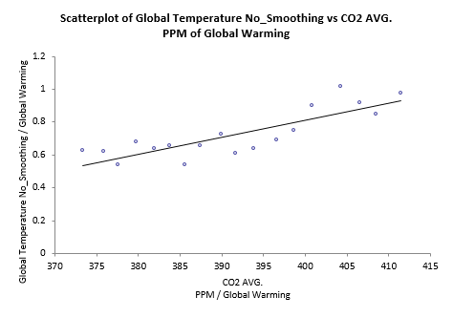

The Global temperature has a strong positive correlation with CO2 being 0.834.

The Global temperature increase has a strong correlation of –0.750 with a consistent decline in the Antarctic mass.

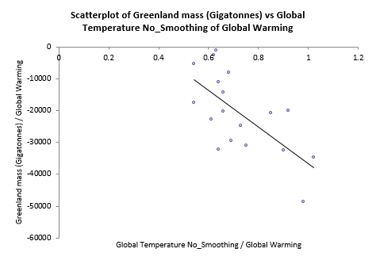

The decline of the Greenland mass and the increase in Global temperature abnormality has strong negative correlation of –0.666.

The Antarctic mass declined along with the GMSL with a strong negative correlation of –0.876.

The GMSL had a steady decrease along with Greenland mass having a strong negative correlation of -0.824.

Table: Correlation

|  |  |  |  |  |  |
| --- | --- | --- | --- | --- | --- |
|  | Global Temperature | CO2 AVG. PPM | GMSL | Antarctic mass (Gigatonnes) | Greenland mass (Gigatonnes) |
| *Linear Correlation Table* | Global Warming | Global Warming | Global Warming | Global Warming | Global Warming |
| Global Temperature | 1.000 | 0.834 | 0.883 | -0.750 | -0.666 |
| CO2 AVG. PPM |  | 1.000 | 0.988 | -0.876 | -0.846 |
| GMLS |  |  | 1.000 | -0.876 | -0.824 |
| Antarctic mass (Gigatonnes) |  |  |  | 1.000 | 0.968 |
| Greenland mass (Gigatonnes) |  |  |  |  | 1.000 |

Regression CO2 and Global temperature abnormality

|  |  |  |  |  |  |  |
| --- | --- | --- | --- | --- | --- | --- |
| *Multiple Regression for Global Temperature Abnomarlity*  *(Celcius)* | Multiple   R | R-Square | Adjusted   R-square | Std. Err. of   Estimate | Rows   Ignored | Outliers |
| *Summary* |  |  |  |  |  |  |
|  | 0.8340 | 0.6956 | 0.6766 | 0.083313597 | 0 | 0 |
|  |  |  |  |  |  |  |
|  | Degrees of   Freedom | Sum of   Squares | Mean of   Squares | F | p-Value |  |
| *ANOVA Table* |  |  |  |  |  |  |
| Explained | 1 | 0.253785957 | 0.253785957 | 36.56249436 | < 0.0001 |  |
| Unexplained | 16 | 0.111058487 | 0.006941155 |  |  |  |
|  |  |  |  |  |  |  |
|  | Coefficient | Standard   Error | t-Value | p-Value | Confidence Interval 95% |  |
| *Regression Table* |  |  |  |  | Lower | Upper |
| Constant | -3.333165005 | 0.671517009 | -4.963634517 | 0.0001 | -4.756717471 | -1.909612539 |
| CO2 AVG.  PPM | 0.010366688 | 0.001714439 | 6.046692845 | < 0.0001 | 0.006732239 | 0.014001137 |

Multiful Regression Antarctic, Greenland and GMSL

|  |  |  |  |  |  |  |
| --- | --- | --- | --- | --- | --- | --- |
| *Multiple Regression for GMSL* | Multiple   R | R-Square | Adjusted   R-square | Std. Err. of   Estimate | Rows   Ignored | Outliers |
| *Summary* |  |  |  |  |  |  |
|  | 0.8815 | 0.7771 | 0.7473 | 9.318222826 | 0 | 0 |
|  |  |  |  |  |  |  |
|  | Degrees of   Freedom | Sum of   Squares | Mean of   Squares | F | p-Value |  |
| *ANOVA Table* |  |  |  |  |  |  |
| Explained | 2 | 4539.445011 | 2269.722506 | 26.14006005 | < 0.0001 |  |
| Unexplained | 15 | 1302.43915 | 86.82927664 |  |  |  |
|  |  |  |  |  |  |  |
|  | Coefficient | Standard   Error | t-Value | p-Value | Confidence Interval 95% |  |
| *Regression Table* |  |  |  |  | Lower | Upper |
| Constant | -4.172815851 | 4.791968147 | -0.870793737 | 0.3976 | -14.38665418 | 6.041022478 |
| Antarctic mass (Gigatonnes) | -0.003586231 | 0.001397432 | -2.566301465 | 0.0215 | -0.006564787 | -0.000607676 |
| Greenland mass (Gigatonnes) | 0.000552246 | 0.00070986 | 0.777963875 | 0.4487 | -0.000960786 | 0.002065277 |

* Modeling 1: CO2 PPM and Global Temperature. The global temperature increases due to increased CO2 which causes global warming.
* Modeling 2: When Global temperatures rise, ice mass in the Antarctic melts.
* Modeling 3: When global temperatures rise, ice mass in Greenland melts.
* Modeling 4: When the Antarctic melts, the sea levels rise.
* Modeling 5: When Greenland melts, the sea levels rise.

## Evaluation

Our findings can be used to better track the correlations between sea level, global temperature, and carbon dioxide levels in order to provide proof and attention to this. We can conclude that the CO2 was 373.28 ppm (1958-2019), but after cleaning the dataset the CO2 mean is 411.44 ppm (2002-2019) caused an increase in average CO2 ppm.

We can conclude that the Global temperature mean was 0.0431 C (1880-2019), but after cleaning the dataset the Global temperature mean is 0.7256 C (2002-2019). CO2 is dependent variable and Global Temperature is independent variable. When CO2 unit is 0 then Global Temperature will be -3.333165005. Our data shows that 1 unit of CO2 will increase Global

## Deployment

Temperature 0.01 C. R-square is 0.6956 that promote is 69.56% of cause factor for Global Temperature.

GMSL is dependent variable and Antarctic mass and Greenland mass are independent variables. When both Antarctic and Greenland mass unit are 0 then GMSL will be –4.1728mm. 1 unit of Antarctic mass and Greenland mass will decrease GMSL-0.003mm. R-square is 0.7717that Antarctic mass and Greenland mass is 77.1% of cause factor for GMSL. However, p-values of Antarctic mass and Greenland mass are 0.0215 and 0.4487. It means Greenland mass is not significantly affect to GMSL changing. The Antarctic mass change affect to GMSL significantly.

This can further prove that there needs to be stricter policies in CO2 emissions from many places on Earth since the Global temperature is gradually increasing at this moment. This change in our evaluation can have us conclude that there are many factors that can affect global temperature which started recording from 1880 the data now from our dataset of 2002 to 2019. This rise in temperature further shows how the Antarctic mass and Greenland mass have been decreasing over the years from 2002 to 2019 which suggest that eventually many parts of Earth can lose living space land. Due to these increases we see an increase in Global temperature to 0.7256 C per year alongside drastic increasing CO2 levels that are causing ice to melt and sea levels to rise at a rate of 15.96 per year.

As citizens and the number one contributor of CO2 emissions we at Air Solutions recommend the leaders of the world to unite and make the required legislation to change our polluting ways. The highest contribution of carbon dioxide levels come from combustion engines like cars, semi-trucks, and airplanes. The data that we discovered should be used as a motive for automotive companies to produce cleaner energy vehicles and has proven to be a profitable source based on European countries that have renewable clean energy such as France, Norway and Germany. Therefore, we have devised a rollout of legislation to be implemented to car consumers and automakers. We propose to ban the production of gas-powered vehicles and incentivize electric and fuel cell automakers.

First, we plan to implement a gas car tax that will be added to gas prices and to the purchase of a gas-powered car. We also propose to give incentives to those who switch to alternative vehicles by adding extra carpool lanes, no charge on tolls and ferries to name a few. This will allow the country to generate funds to invest in research and development for automakers, and to build infrastructure for fuel cell and electric car charging and fueling stations. This part will hold citizens accountable for their carbon footprint to help eliminate as much CO2 emissions as possible

It’s also important to change the way goods are currently being transported such as airline deliveries, cargo ships, and delivery vehicles. Corporations hold a greater responsibility to change the way they currently transport goods. We recommend holding corporations responsible and have a polluters tax for every semi-truck that is current trucks as soon as they become available by automakers like Tesla who are currently in the production phase of these electric powered trucks. The change in transportation vehicles will provide a significant decrease of the carbon dioxide levels that can help better the environment and atmosphere. According to the United Sates Environmental Protection agency CO2 emissions in 2017 was most accounted by transportation, if we could eliminate all gas-powered cars by 2040, we can assume a drop of 29% of CO2 emissions.

## Conclusion

The models that we have developed show how carbon dioxide levels, global temperature and sea levels have a strong correlation of 0.834. The GMSL and global temperature anomality have a strong correlation of 0.883. We will advise our business that the temperature increase on Earth is from increasing carbon dioxide levels over the past years since 2002. The carbon dioxide is produced from man-made technology that emit fumes or chemicals into the atmosphere, therefore causing a consistently rising temperature increase. The rising levels of carbon dioxide must be decreased from their current high of 415 ppm to below 200 ppm by 2040 since every area of Earth is being affected.

## Glossary

* California Naturalist - The California Naturalist is intimately connected to nature, and our ecosystems provide a home to 40 million people. Our natural home directly influences our water quality, air quality, food production, and ultimately our health. The California Naturalist responsible for maintenance, but California’s ecosystems don’t come with a user’s manual.
* CO2 – Carbon dioxide (CO2) is an important heat-trapping (greenhouse) gas, which is released through human activities such as deforestation and burning fossil fuels, as well as natural processes such as respiration and volcanic eruptions.
* Glacier - a persistent body of dense ice that is constantly moving under its own weight.
* Global temperature anomality - In the natural sciences, especially in atmospheric and Earth sciences involving applied statistics, an anomaly is the deviation in a quantity from its expected value, e.g., the difference between a measurement and a mean or a model prediction.
* GMSL (Global mean sea level ) - The GMSL is a 1-dimensional time series of globally averaged Sea Surface Height Anomalies (SSHA) from TOPEX/Poseidon, Jason-1, OSTM/Jason-2 and Jason-3.
* Greenhouse effect - a gas that absorbs and emits radiant energy within the thermal infrared range. The primary greenhouse gases in Earth's atmosphere are water vapor, carbon dioxide, methane, nitrous oxide, and ozone.
* Ice sheet - An ice sheet, also known as a continental glacier,[1] is a mass of glacial ice that covers surrounding terrain and is greater than 50,000 km2 (19,000 sq mi).[2] The only current ice sheets are in Antarctica and Greenland
* Methane - a chemical compound with the chemical formula CH₄. It is a group-14 hydride and the simplest alkane, and is the main constituent of natural gas
* NASA - The National Aeronautics and Space Administration is an independent agency of the United States Federal Government responsible for the civilian space program, as well as aeronautics and aerospace research
* Ppm - This is a way of expressing very dilute concentrations of substances. Just as per cent means out of a hundred, so parts per million or ppm means out of a million. Usually describes the concentration of something in water or soil. One ppm is equivalent to 1 milligram of something per liter of water (mg/l) or 1 milligram of something per kilogram soil (mg/kg).
* Sea level - an average level of the surface of one or more of Earth's bodies of water from which heights such as elevation may be measured.
* Solar Irradiance - the power per unit area, received from the Sun in the form of electromagnetic radiation as reported in the wavelength range of the measuring instrument
* Water vapor - gaseous phase of water

## References

Climate Change: Vital Signs of the Planet. (2020, March 9). Retrieved from <https://climate.nasa.gov/>

EU agrees on 37.5% CO2 reduction for cars by 2030. (2018, December 18). Retrieved from <https://www.euractiv.com/section/transport/news/eu-agrees-on-37-5-co2-reduction-for-cars-by-2030/>

NASA Global Climate Change. (2020, 9). Global Surface Temperature | NASA Global Climate Change. Retrieved from <https://climate.nasa.gov/vital-signs/global-temperature/>

NASA Global Climate Change. (2020, March 9). Carbon Dioxide Concentration | NASA Global Climate Change. Climate Change: Vital Signs of the Planet. Retrieved from <https://climate.nasa.gov/vital-signs/carbon-dioxide/>

NASA Global Climate Change. (2020, March 9). Global Surface Temperature | NASA Global Climate Change. Climate Change: Vital Signs of the Planet. Retrieved from <https://climate.nasa.gov/vital-signs/global-temperature/>

NASA Global Climate Change. (2020, March 9). Global Surface Temperature | NASA Global Climate Change. Retrieved from <https://climate.nasa.gov/vital-signs/global-temperature/>

NASA Global Climate Change. (2020, March 9). Ice Sheets | NASA Global Climate Change. Climate Change: Vital Signs of the Planet. Retrieved from <https://climate.nasa.gov/vital-signs/ice-sheets/>

NASA Global Climate Change. (2020, March 9). Sea Level | NASA Global Climate Change. Climate Change: Vital Signs of the Planet. Retrieved from <https://climate.nasa.gov/vital-signs/sea-level/>

Sea Level Rise. (2018, November 7). Retrieved from <https://www.climatecentral.org/what-we-do/our-programs/sea-level-rise>

Villas-Boas, A. (2020, January 30). Tesla says you'll start seeing its futuristic Semi on the road this year. Retrieved from <https://www.businessinsider.com/tesla-semi-will-roll-off-production-line-in-2020-2020-1>

What Will Happen As The World Gets Warmer? (2015, December 12). Retrieved from <https://news.sky.com/story/what-will-happen-as-the-world-gets-warmer-10336299>

Winton, N. (2020, February 5). Britain Plans To Ban Sales Of New Gasoline Cars By 2035, But Details Are Fuzzy. Retrieved from <https://www.forbes.com/sites/neilwinton/2020/02/04/britains-plan-to-ban-sales-of-new-gasoline-cars-in-2035-lacks-detail/#16399e416b59>